MONGODB ASSIGNMENT A
- Create a new database called student_management.
use student_management

- Create a collection called students in the student_management database.
db.createCollection("students")

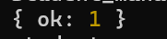

- Insert at least five student records into the students collection. Each record should have the following fields:
- student_id (integer)
- name (string)
- age (integer)
- department (string)
- courses (array of strings)
- grade (string)

db.students.insertMany([
{ student_id: 101, name: "Alice", age: 20, department: "Computer Science", courses: ["Database Systems", "Algorithms"], grade: "B" },
{ student_id: 102,name: "Bob", age: 22, department: "Information Technology",
courses: ["Networking", "Database Systems"], grade: "A" },
{ student_id: 103, name: "Charlie",age: 23, department: "Computer Science",
courses: ["Operating Systems", "Data Structures"], grade: "C" },
{student_id: 104,name: "Diana", age: 21,department: "Electronics",courses:["Signals", "Database Systems"], grade: "A" },
{student_id: 105,name: "Ethan",age: 19,department: "Computer Science",
courses: ["Networking", "Algorithms"], grade: "D" }])
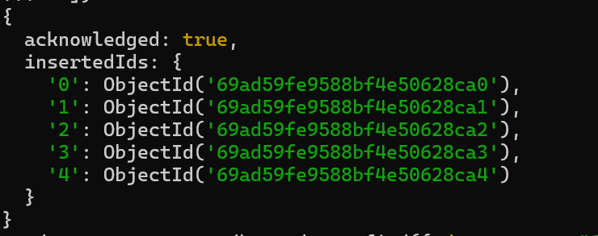

- Query the Collection:
Write queries to perform the following tasks:
- Retrieve all students who are in the "Computer Science" department.
db.students.find({ department: "Computer Science" })
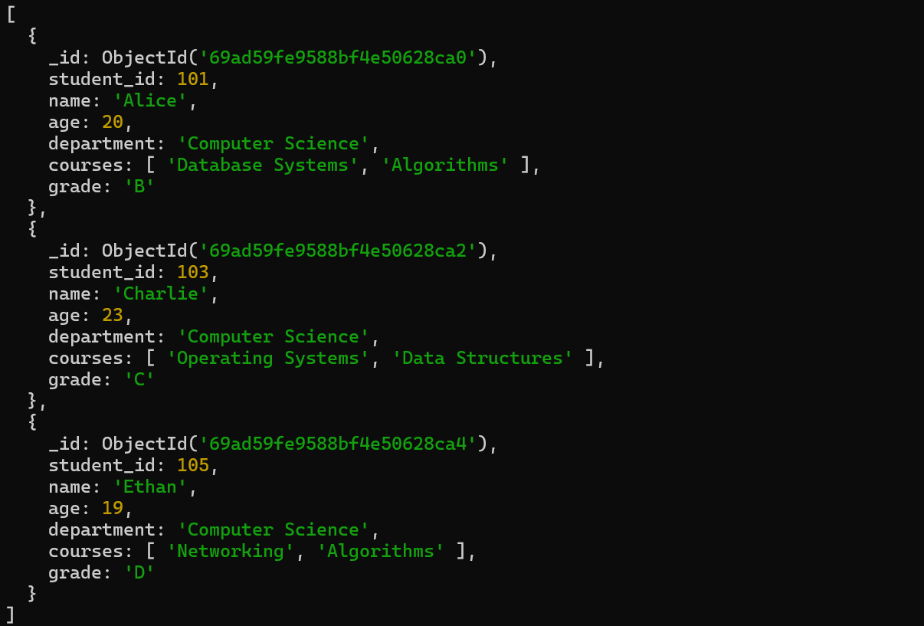

- Retrieve students who have an age greater than 21.
db.students.find({ age: { $gt: 21 } })
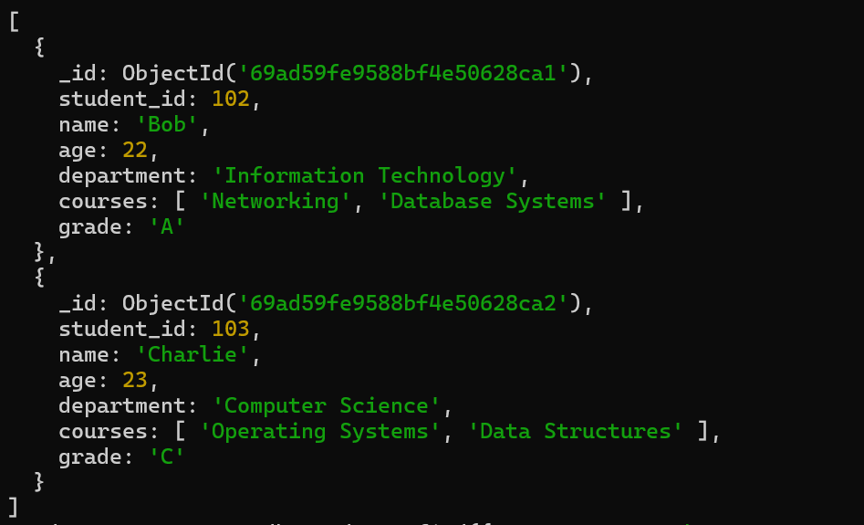

- Retrieve students who are taking the "Database Systems" course.
db.students.find({ courses: "Database Systems" })

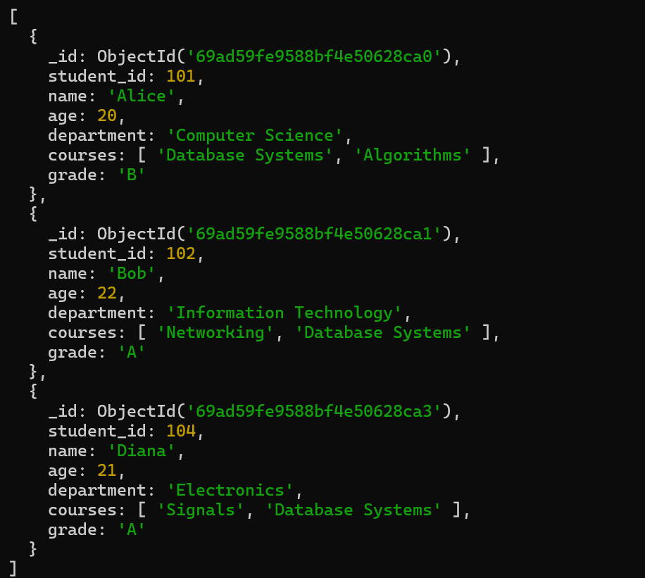
- Retrieve students with a grade of "A".
db.students.find({ grade: "A" })

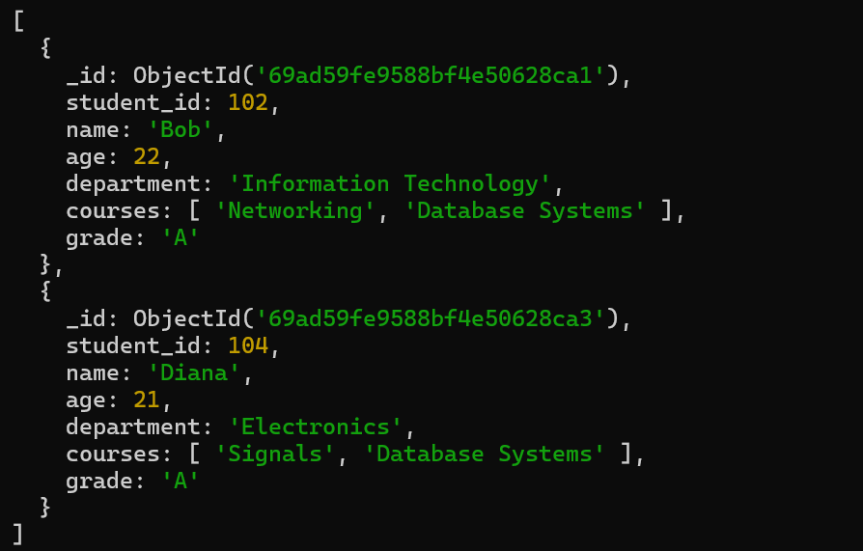

- Update Documents:
- Update the age of a student with student_id 101 to 21.
db.students.updateOne({ student_id: 101 }, { $set: { age: 21 }})
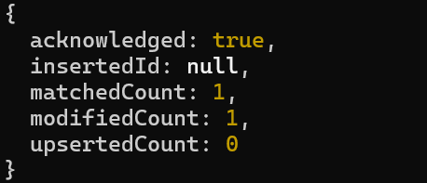

- Add a new course, "Machine Learning", to the courses array for students in the "Computer Science" department.
db.students.updateMany({ department: "Computer Science" }, { $addToSet: { courses: "Machine Learning" } })

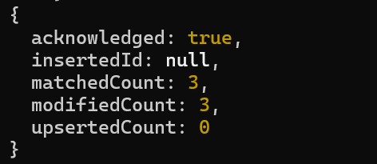

- Delete Documents:
- Delete a student record with student_id 105.
db.students.deleteOne({ student_id: 105 })
- Delete all students who have a grade lower than "C".
db.students.deleteMany({ grade: { $in: ["D", "F"] } })
